Use-Case Realization Report
View Schedule

Issue <1.0>
Revision History
Date | Issue | Description | Author
<29/apr/11> | <1.0> | Initial Document | Koh Ming Jin

Table of Contents
1. Brief Description 4
2. Flow of Events 4
2.1 Standard Flow 4
2.2 Exception 4
3. Interaction Diagrams 4
3.1 Collaboration Diagram for View Schedule 4
4. Participating Objects 4
4.1 Schedule 4
4.2 View Schedule Screen 4
5. Class Diagrams 5
5.1 Domain Class Diagram: View Schedule 5
6. Derived Requirements 5

Use-Case Realization Report
View Schedule

Brief Description
This use case enables an operation manager to view a schedule for a particular process step.

Flow of Events
The standard flow of events for this use case and any exceptions are described in the following subsections. See section 3.1 for an overview of the participating Actors and Domain Objects.

Standard Flow
The flow of events is described as follows:

- The use case starts when Operation Manager selects the View Schedule option of the system.
- The Schedule Panel, which includes all the Schedule details, is displayed.
- The use case terminates.

Exception
- NIL

Interaction Diagrams

Collaboration Diagram for View Schedule
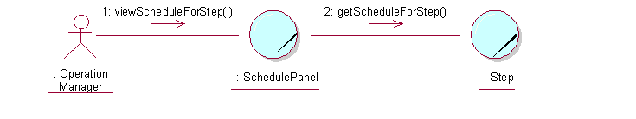

Participating Objects

Schedule
This object stores the details concerning the Schedule of the COMS.

View Schedule Screen
This screen is used for displaying all the Schedule details. The Director, Department Manager and Operation Manager actors use this object.

Class Diagrams

Domain Class Diagram: View Schedule
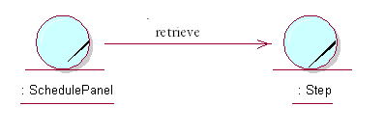

Derived Requirements
The Operation Manager PC keyboard and mouse will be used to enter Schedule details (if any) and view all the system responses.

